COMPARISON OF CONSTRAINTS BETWEEN INITIAL AND NEW CODE
# Flow constraints
# Ensures route continuity for each vehicle k:
# - A vehicle leaves the start node (id0) and returns to the end node (idend) if and only if it is used (z[k] = 1).
# - For every intermediate node i (not id0 or idend), the number of arcs entering equals the number of arcs leaving for
# each vehicle, maintaining flow conservation.
# This guarantees that each vehicle’s route is complete, begins and ends at the depot, and has no disjoint or broken segments.
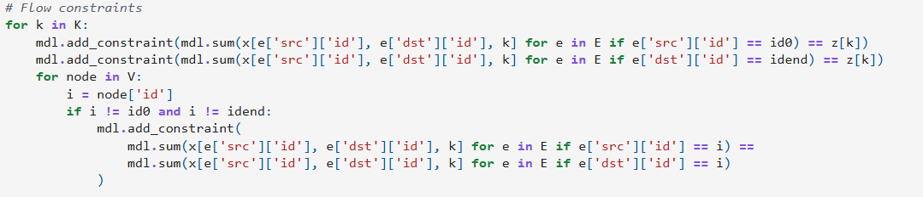
Mathematical equation
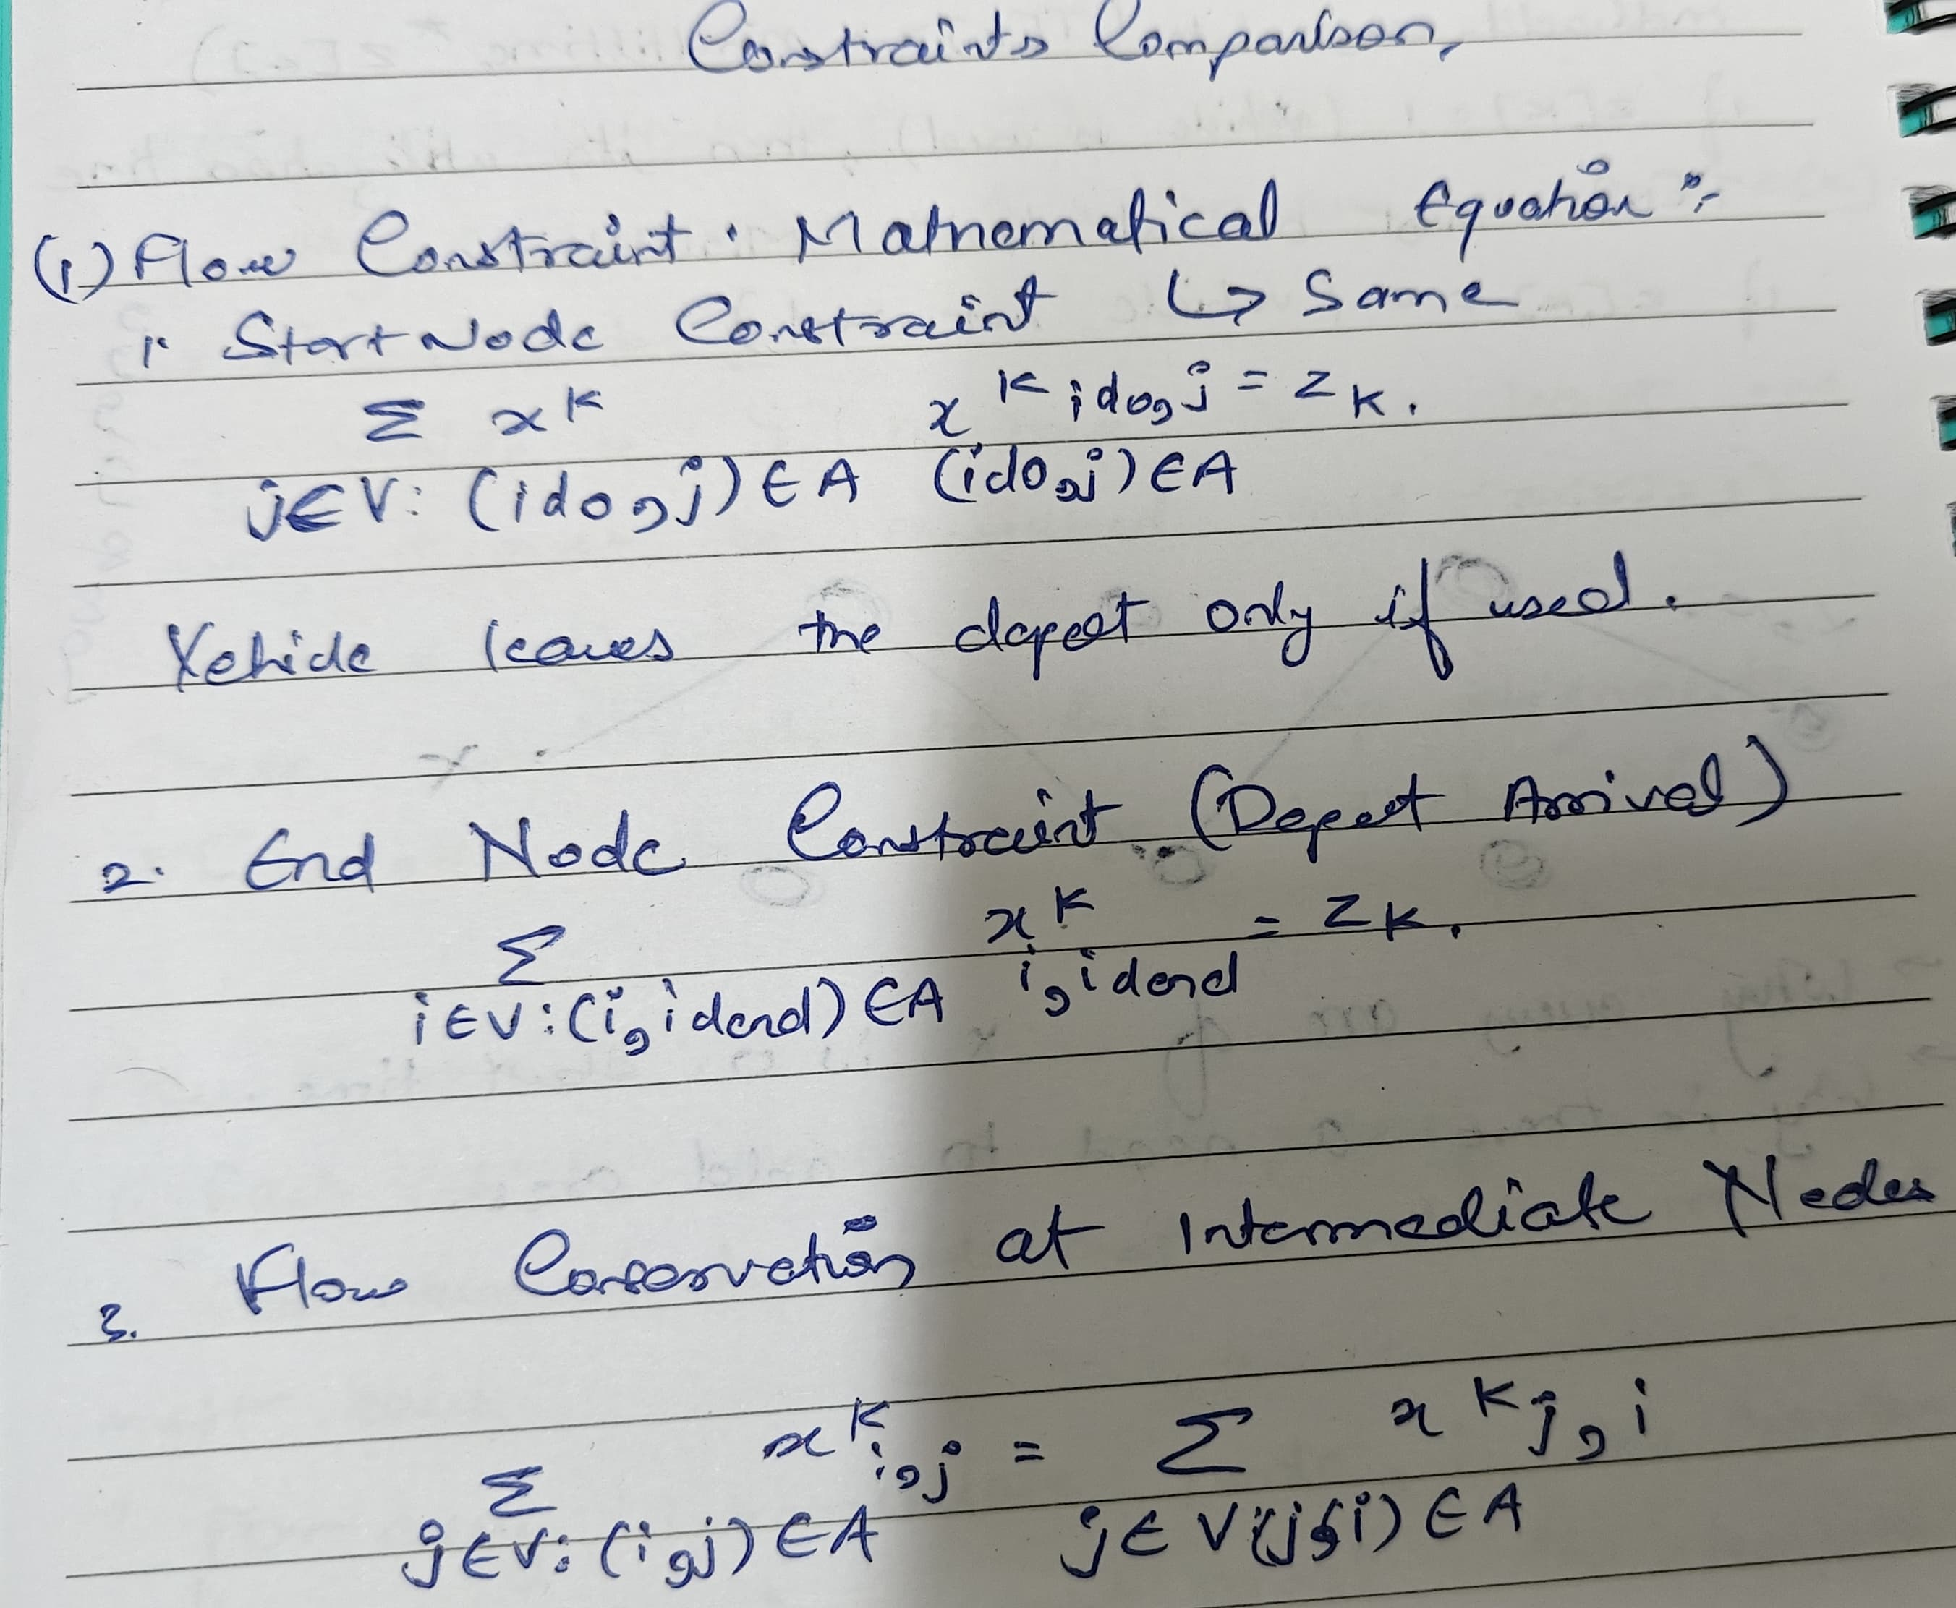

# Utilization time calculation
# Calculates and constrains the utilization time T[k] for each vehicle k:
# - The first constraint computes T[k] as the total cost (e.g., time or distance) of scheduled trips (cap = 1) assigned to vehicle k.
# - The second constraint enforces a minimum utilization threshold (MinUtilTime) for used vehicles, preventing inefficient deployment.
# - The third constraint enforces a maximum utilization limit (MaxUtilTime) for used vehicles, maintaining compliance with shift length, energy, or legal restrictions.
# Together, these ensure vehicles are neither underused nor overused while maintaining route feasibility.
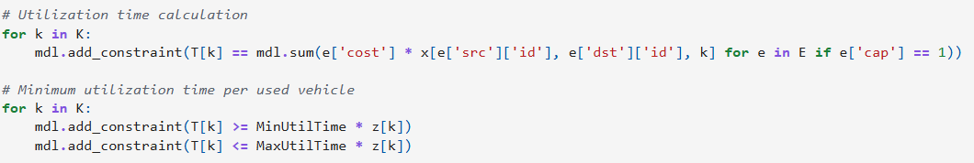

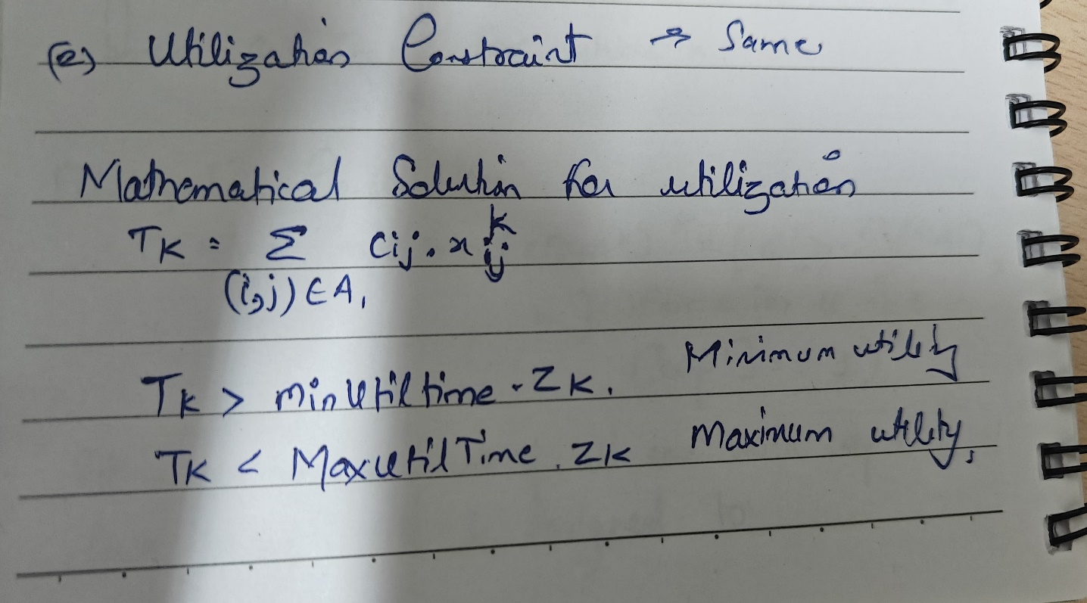

# Single Vehicle Per Arc
# Ensures that each real scheduled trip (i.e., arcs with cap = 1) is assigned to at most one vehicle.
# This prevents multiple vehicles from being assigned to the same trip, maintaining schedule feasibility
# and eliminating redundant or duplicate servicing.

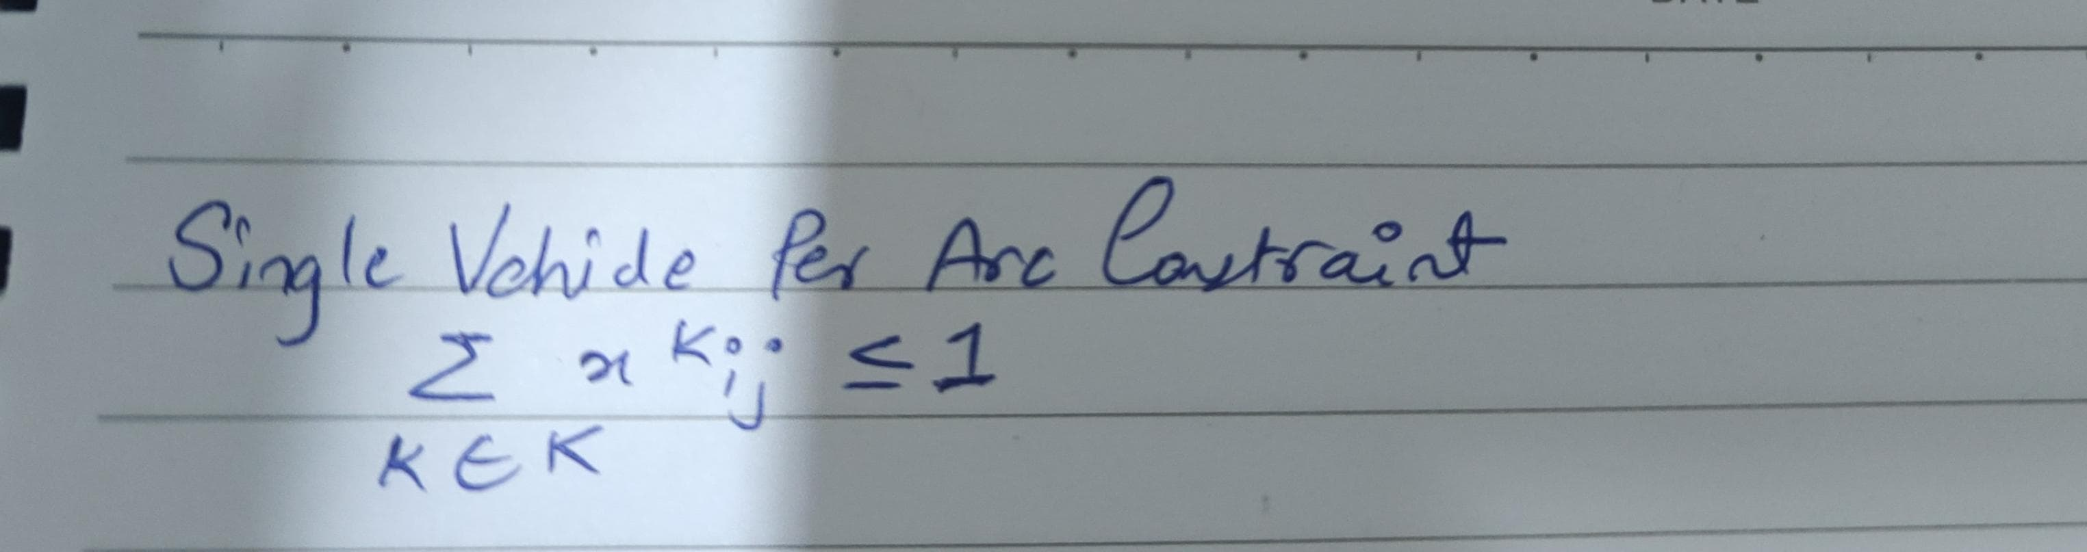
TIME PROPAGATION
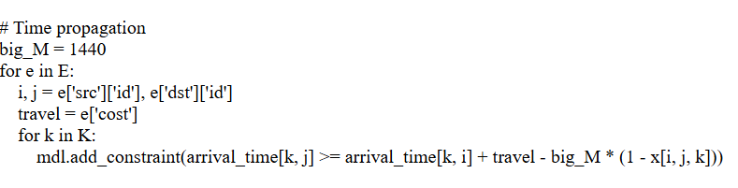
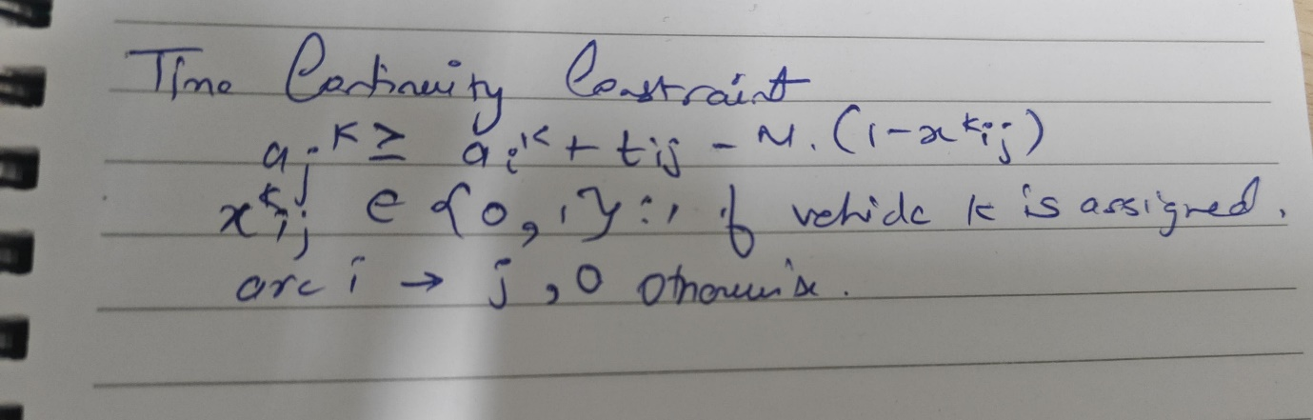
# Frequency constraints
# Ensures that during each hour h, the total number of trips departing from ATB and HSK (assigned across all vehicles) meets the required minimum frequency, allowing shortfalls via slack variables that are penalized in the objective to maintain service reliability.

